Title of the paper
Author’s name and surname
Affiliation, Institution, Address, e-mail
Author’s name and surname
Affiliation, Institution, Address, e-mail
Author’s name and surname
Affiliation, Institution, Address, e-mail
Abstract
Landscape architecture is the design of outdoor areas, landmarks, and structures to achieve environmental, social-behavioural, or aesthetic outcomes. It involves the systematic investigation of existing social, ecological, and soil conditions and processes in the landscape, and the design of interventions that will produce the desired outcome…
(max. 1400 characters including spaces)
Keywords: Keyword 1, Keyword 2, Keyword 3, etc. (max 5 words)

Introduction
Landscape architecture is a multi-disciplinary field, incorporating aspects of botany, horticulture, the fine arts, architecture, industrial design, soil sciences, environmental psychology, geography, ecology, and civil engineering. The activities of a landscape architect can range from the creation of public parks and parkways to site planning for campuses and corporate office parks, from the design of residential estates to the design of civil infrastructure and the management of large wilderness areas or reclamation of degraded landscapes such as mines or landfills…
Title of the paragraph
Landscape architects work on structures and external spaces with limitations toward the landscape or park aspect of the design - large or small, urban, suburban and rural, and with "hard" (built) and "soft" (planted) materials, while integrating ecological sustainability. The most valuable contribution can be made at the first stage of a project to generate ideas with technical understanding and creative flair for the design, organization, and use of spaces. The landscape architect can conceive the overall concept and prepare the master plan, from which detailed design drawings and technical specifications are prepared. They can also review proposals to authorize and supervise contracts for the construction work. Other skills include preparing design impact assessments, conducting environmental assessments and audits, and serving as an expert witness at inquiries on land use issues.
Title of the paragraph
Landscape managers use their knowledge of landscape processes to advise on the long-term care and development of the landscape. They often work in forestry, nature conservation and agriculture. Landscape scientists have specialist skills such as soil science, hydrology, geomorphology or botany that they relate to the practical problems of landscape work. Their projects can range from site surveys to the ecological assessment of broad areas for planning or management purposes. They may also report on the impact of development or the importance of particular species in a given area.
Title of the sub-paragraph
Landscape planners are concerned with landscape planning for the location, scenic, ecological and recreational aspects of urban, rural and coastal land use. Their work is embodied in written statements of policy and strategy, and their remit includes master planning for new developments, landscape evaluations and assessments, and preparing countryside management or policy plans. Some may also apply an additional specialism such as landscape archaeology or law to the process of landscape planning…
Table 1: Table title
 | Title of the column | Title of the column
Title of the row | text/value | text/value
Title of the row | text/value | text/value
Title of the row | text/value | text/value
Title of the sub-paragraph
Green roof designers design extensive and intensive roof gardens for storm water management, evapo-transpirative cooling, sustainable architecture, aesthetics, and habitat creation…
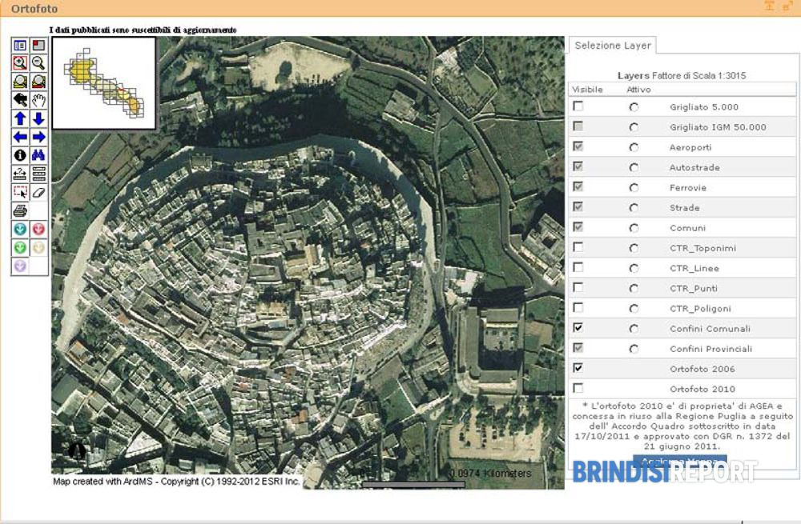
Figure 1: Figure title (style: Figure title) - Authors are requested to respect the copyrights of sources that have been takenfrom other authors or organizations. Figure size 300dpi
Conclusions
Through the 19th century, urban planning became a focal point and central issue in cities. The combination of the tradition of landscape gardening and the emerging field of urban planning offered Landscape Architecture an opportunity to serve these needs.[11] In the second half of the century, Frederick Law Olmsted completed a series of parks which continue to have a huge influence on the practices of Landscape Architecture today...
References
Book:
Okuda, Michael, and Denise Okuda. 1993. Star trek chronology: The history of the future. New York: Pocket Books.
Book chapter:
Ramírez, Ángeles. 2010. “Muslim Women in the Spanish Press: The Persistence of Subaltern Images.” In Muslim Women in War and Crisis: Representation and Reality, edited by FaeghehShirazi, 227–44. Austin: University of Texas Press.
Journal article:
Bogren, Alexandra. 2011. “Gender and Alcohol: The Swedish Press Debate.” Journal of Gender Studies 20, no. 2 (June): 155–69.
Internet source:
Google. 2012. “Privacy Policy.” Google Policies & Principles. Last modified July 27. Accessed January 3, 2013. http://www.google.com/policies/privacy/.
Blog entry or comment:
Becker, Gary. 2012. “Is Capitalism in Crisis?” The Becker-Posner Blog, February 12. Accessed February 16, 2012. http://www.becker-posner-blog.com/2012/02/is-capitalism-in-crisis-becker.html.
The list of references should be arranged alphabetically.

Additional note:
The paper should be named as follows: BORGHI 19_TOPIC 1_ paper_name_surname.docx
Full papers should be submitted by web site.
Authors are asked to respect and use established styles and defined maximum of characters (max. 14000 including spaces), maximum 8 pages (including images) and images (max. 6, TIFF format, 300 dpi, also attached as separate images in the dimension 21x21 cm) for the full paper.

